**COIT 20248**

**Information Systems Analysis and Design**

**Term 2, 2019**

**Assignment 2**

**Repair-Made-Easy (RME) Information System**

Lecturer: Sanjay Jha

Tutor: Sanjay Jha

Prepared by:

Bishal Budhathoki (12116421)

Rabina Prajapati (12117176)

Sakar Sainju (12120342)

Ajay Mall (12123341)

Contents

1. Introduction 1

1.1. Aims and Objectives 1

2. Use Case Diagram 2

2.1 Critical Use Cases: 4

3. Context Level Diagram 8

4. Data Flow Diagram 9

5. ER Diagram 10

6. Data Elements 12

7. CRUD 15

8. Website Prototype 16

9. Individual Contribution 20

10. Conclusion 22

11. References 23

# 1. Introduction

Repair-Made-Easy (RME) Inc, a store located in the city of Melbourne, Australia provides spare parts and services for a wide range of computers that include desktop and notebooks. All the transactions of RME are maintained manually on a spreadsheet by the staff. Since RME is planning to increase its market in a different place, the manual work system of maintaining a record on the spreadsheet becomes inefficient and time-consuming. However, the existing system that the organization performs is not efficient and as a result, the development of the new web-based system that runs through the internet has been proposed. This report takes the project into the development of a prototype and different conceptual diagrams to determine the working procedure of the developing software.

## Aims and Objectives

The aim of this report is to produce a series of models of the overall system from different perspectives to understand all the aspects of the requirements and eventually generate a prototype. The model-based requirement analysis of the system not only helps visualize the requirements but also be problem oriented.

The objectives that will help to realize the aim are as follows:

* To determine all the possible use cases and context of the system through UML diagrams.
* To predict the data flow of all the operations.
* To understand and integrate different entities and their relations to each other through ERD diagram.
* To visualize different entities and their operational authorities using CRUD diagram.
* To list out data elements supposedly stored on database.
* Develop a proposed prototype of the website.

# 2. Use Case Diagram

Use-case is a methodology that uses a diagram to analyze the system requirements to organize the system. Use-case is used extensively regardless of the approach to system development. It consists of actors and use case symbols, along with connecting lines. (Kendall & Kendall 2011). Here, humans are actors who interact with the system to achieve specific goals by interacting with the system. The important use cases of the system are called critical use cases. The functional requirements of the system can be identified with the help of this use case.

|  |  |
| --- | --- |
| Use Case Name: Customer ID/Number | |
| Actors | Admin, customer, corporate customer |
| Preconditions | Needs account already |
| Events flow | By default, Customer ID/Number is created when creating account |
| Post conditions | 1) The Customer ID/Number will be displayed |

|  |  |
| --- | --- |
| Use Case Name: Employee ID/Number | |
| Actors | Admin, employee |
| Preconditions | Needs employee account already |
| Events flow | By default, Employee ID/Number is created when creating account |
| Post conditions | The Employee ID/Number will be displayed |

|  |  |
| --- | --- |
| Use Case Name: Inventory Display | |
| Actors | Admin, Employee |
| Preconditions | Account must be created and be existing |
| Events flow | 1. Add/Remove inventory option 2. Fill inventory types with details 3. Display warning message for confirmation 4. Then Ok |
| Post conditions | 1. Updated inventory will be displayed |

|  |  |
| --- | --- |
| Use Case Name: Cart | |
| Actors | Customer, Corporate customer |
| Preconditions | Account must be created and be existing and logged in. |
| Events flow | 1. Select item 2. Add to cart option 3. Checkout for purchasing the product 4. Secure payment form fill up |
| Post conditions | 1) Order received invoice to customers |

|  |  |
| --- | --- |
| Use Case Name: Alerts | |
| Actors | Admin, stakeholders |
| Preconditions | Person must be stakeholder or admin |
| Events flow | 1) Alerts for low in inventory, supplies arrivals, product sold is given |
| Post conditions | 1) Employees and necessary individual will be notified. |

|  |  |
| --- | --- |
| Use Case Name: Financial Report | |
| Actors | Admin, Employee |
| Preconditions | Person must be employee or admin |
| Events flow | 1. Select Financial detail button 2. System will auto generate the financial records 3. Select print if necessary 4. Press Ok. |
| Post conditions | 1) Employees and Admin will be notified. |

## 2.1 Critical Use Cases:

|  |  |
| --- | --- |
| Use Case Name: Create Account/Sign-up | |
| Actors | Admin, customer, supplier, corporate customer, employee |
| Preconditions | Valid email address is required |
| Events flow | 1)Select option displaying Create account  2) Give all the necessary details  3) Then continue |
| Post conditions | 1) Successful creation of account message if the details are correct  2) Failure to create account message if the details are wrong |

|  |  |
| --- | --- |
| Use Case Name: Log In | |
| Actors | Admin, customer, supplier, corporate customer, employee |
| Preconditions | Valid email address and password is required |
| Events flow | 1)Enter username / e-mail and password  2) Select login button. |
| Post conditions | 1) If password and username / e-mail matched, display homepage of the IS.  2) If Username/ e-mail or password is incorrect then alert the individual displaying wrong input and try again with correct detail. |

|  |  |
| --- | --- |
| Use Case Name: Place Orders | |
| Actors | Admin, Employee, Customer, Corporate customer |
| Preconditions | Account must be created and be existing and logged in. |
| Events flow | 1. Select order 2. Add more orders if required 3. Select item and quantity 4. Place order 5. Payment 6. Verification |
| Post conditions | 1) Order received invoice to individual actors. |

|  |  |
| --- | --- |
| Use Case Name: Access Control | |
| Actors | Admin, Customer, Supplier, Corporate customer, Employee |
| Preconditions | Account must be already created |
| Events flow | Information System identifies the account type |
| Post conditions | Required related information will only be displayed |

|  |  |
| --- | --- |
| Use Case Name: Make Payment | |
| Actors | Customer, Supplier, Corporate customer, |
| Preconditions | Account must be already created |
| Events flow | 1. Information System identifies the account type, if corporate customer monthly billed. 2. Select delivery address or in-house service 3. Enter Bank details or card details 4. OTP verification 5. Accept and print invoice and mail invoice to customers. |
| Post conditions | Required related information will only be displayed |

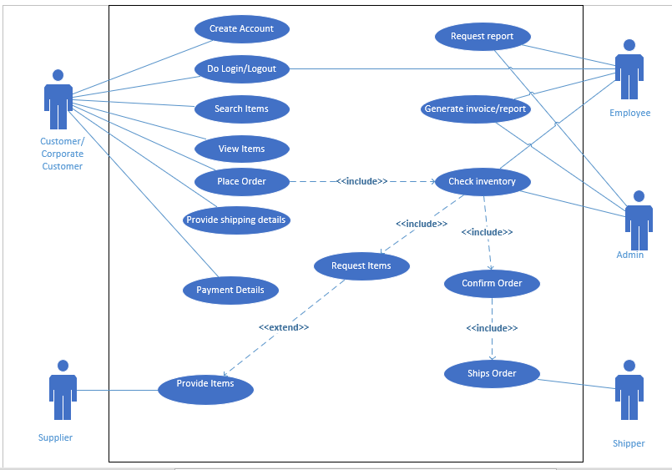

Figure 1: Use Case Diagram of RME Information System

The above diagram represents how the actors interacts with different functionalities of RME Information System. The actors for the system are Admin, Customer, Supplier, Shipper and Employee and the use cases are Signup, Login/Logout, Search Items, View Items, Ship Order and so on.

# 3. Context Level Diagram

Context Level diagram is the diagrammatic representation of the highest level of all process of a data flow diagram which contains only a process that represents the whole system. All the processes are usually denoted by the digit 0 (Kendall and Kendall, 2011). It is also referred to as the initial level (Level 0) of the data flow diagram, which indicates the boundary of the system, external entities and the cooperation of the external entities with the system. It shows the relationship between the system and external entities like different systems, processes, organizational groups and databases. The context level diagram is like the blueprint of the system that shows all the scope and boundaries within the system. It is considered as a prototype of the system and is made at the beginning of the project as it helps to provide shape to the project providing rigid direction for completion. The following is the context level diagram of the Repair-Made-Easy (RME) Information System.

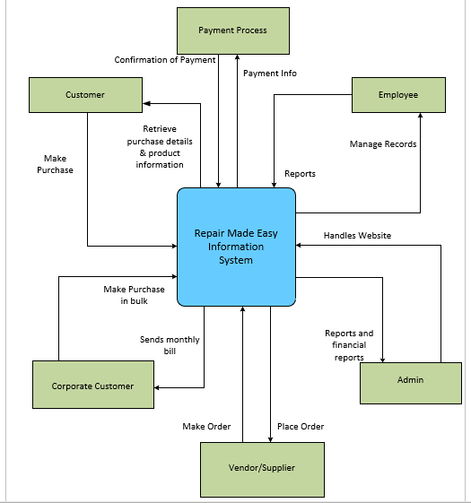

# 4. Data Flow Diagram

Figure 2: Context Level Diagram of RME Information System

Data Flow Diagram (DFD) is a diagrammatical presentation of data flow in the system. It is the expanded version of context diagram that means there are more number of processes with data flow, data store, processes, and data sink/source. This helps in logical flow of information in the system and helps analyst know the system well.

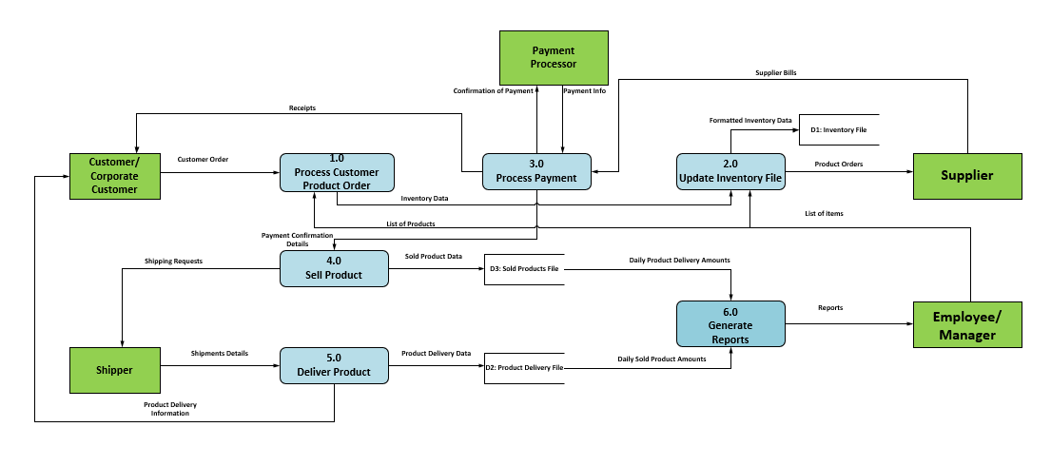

# 

Figure 3: Data Flow Diagram of RME Information System

Following are processes used in the diagram:

1. Processes customer product order
2. Update inventory file
3. Process payment
4. Sell product
5. Deliver product
6. Generate reports

The different data flows are:

1. Customer order
2. Inventory data
3. List of products
4. Receipts
5. Confirmation of payment
6. Payment info
7. Payment confirmation Details
8. Shipping details
9. Product delivery information
10. Sold product data
11. Product delivery data
12. Supplier bills
13. Formatted inventory data
14. Product orders
15. List of items
16. Reports
17. Daily product delivery amounts
18. Daily sold product amounts

# 5. ER Diagram

Entity relationship diagram displays the relation of entity set that are stored in database. It helps us to identifies the entities that exist in the system and relationships between them. Firstly, all the entities are identified to draw the ER diagram. An entity refers to an object where we can store information. Attributes are encapsulated within the entity shapes and are used to identify instance of an entity. The relationships connectors are used to show association between entities and arrowheads are used to describe the cardinality.

The diagram below represents the relationship between entities. The diagram consists of entities like Customer, Employee, Admin, Payment Processor and Supplier. Attributes are used and keys are used to connect the attributes of entities. Primary and foreign key are used to connect between attributes and cardinality are also shown. There are different types of cardinalities like one to one, one to many, many to many.

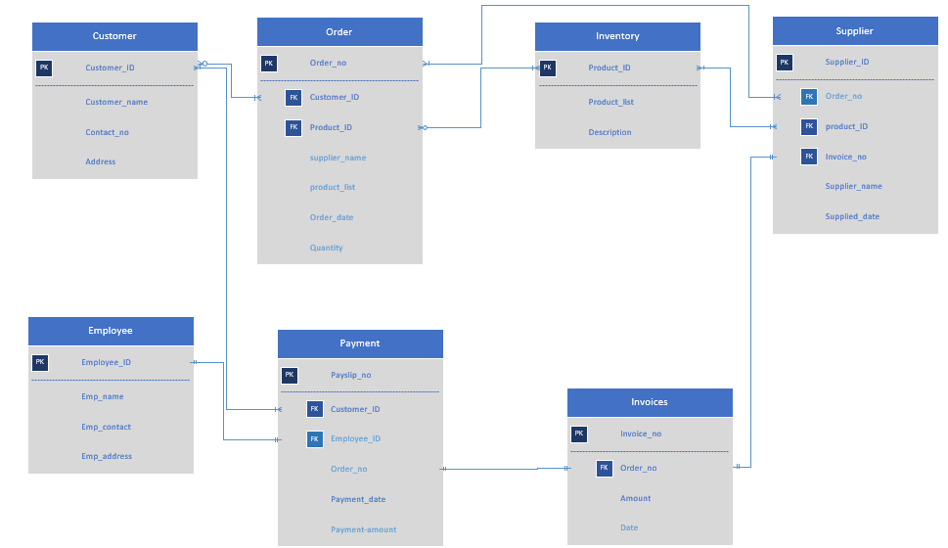

Figure 4: Entity Relationship Diagram of RME Information System

# 6. Data Elements

The following are the data elements that are used in the database of the RME Information System.

* Customer

|  |  |  |  |  |
| --- | --- | --- | --- | --- |
| S. N | Attribute Name | Data Types | Size | Constraints |
|  | Customer_Id | Integer | 10 | Primary key |
|  | Customer_name | Variable character | 20 |  |
|  | Contact_no | Integer | 10 |  |
|  | Address | Variable character | 50 |  |
|  | Email | Variable character | 20 |  |

* Order

|  |  |  |  |  |
| --- | --- | --- | --- | --- |
| S. N | Attribute Name | Data Types | Size | Constraints |
|  | Order_no | Integer | 10 | Primary key |
|  | Customer_Id | Integer | 10 | Foreign Key |
|  | Product_Id | Integer | 10 | Foreign Key |
|  | Supplier_name | Variable Character | 20 |  |
|  | Product_list | Variable Character | 50 |  |
|  | Order_Date | Date Time | 10 |  |
|  | Quantity | Integer | 10 |  |
|  | Email | Variable Character | 20 |  |

* Employee/Admin

|  |  |  |  |  |
| --- | --- | --- | --- | --- |
| S. N | Attribute Name | Data Types | Size | Constraints |
|  | Employee_Id | Integer | 10 | Primary key |
|  | Emp_name | Variable character | 20 |  |
|  | Role | String | 15 |  |
|  | Emp_contact | Integer | 10 |  |
|  | Emp_address | Variable character | 50 |  |
|  | Email Id | Variable Character | 15 |  |

* Supplier

|  |  |  |  |  |
| --- | --- | --- | --- | --- |
| S. N | Attribute Name | Data Types | Size | Constraints |
|  | Supplier_ID | Integer | 10 | Primary Key |
|  | Order_no | Integer | 10 | Foreign key |
|  | Product_ID | Integer | 10 | Foreign key |
|  | Invoice_no | Integer | 10 | Foreign key |
|  | Supplier_name | Variable Character | 20 |  |
|  | Supplied_date | Date Time | 10 |  |

* Inventory

|  |  |  |  |  |
| --- | --- | --- | --- | --- |
| S. N | Attribute Name | Data Types | Size | Constraints |
|  | Product_ID | Integer | 10 | Primary Key |
|  | Product_list | Variable Character | 15 |  |
|  | Description | Variable Character | 50 |  |

* Payment

|  |  |  |  |  |
| --- | --- | --- | --- | --- |
| S. N | Attribute Name | Data Types | Size | Constraints |
|  | Payslip_no | Integer | 10 | Primary Key |
|  | Customer_ID | Integer | 10 | Foreign key |
|  | Employee_ID | Integer | 10 | Foreign key |
|  | Order_no | Integer | 10 | Foreign key |
|  | Payment_date | Date Time | 10 |  |
|  | Payment_amount | Integer | 15 |  |

* Invoices

|  |  |  |  |  |
| --- | --- | --- | --- | --- |
| S. N | Attribute Name | Data Types | Size | Constraints |
|  | Invoice_no | Integer | 10 | Primary Key |
|  | Order_no | Integer | 10 | Foreign key |
|  | Amount | Integer | 10 |  |
|  | Date | Date Time | 10 |  |

# 7. CRUD

A CRUD diagram shows what processing types a system performs on data, indicating them for each function in a matrix format. The kinds are defined as "Create," "Read," "Update," and "Delete," which are the kinds of operations when a database management system (DBMS) manipulates information. After the initials of these kinds, the diagram is called CRUD.

For example, if the "Product name change function" is used to change the data recorded as the "Product name" in the database, a CRUD diagram that places functions in columns and data in rows will show "Update" at the intersection of the "Product name change function" (column) and the "Product name" (row).

When used in a system's design phase, a CRUD diagram enables to check whether certain features are absent, omission of database inquiries, and concentration of processing duties, etc.

**CRUD Matrix**

|  |  |  |  |  |  |  |
| --- | --- | --- | --- | --- | --- | --- |
| Entities  Attributes | Customer | Supplier | Employee | Admin | Orders | Inventory |
| Create Account | **C** | **C** |  | **C** |  |  |
| Search Items | **R** | **R** |  |  |  |  |
| Customer Order | **CRU** |  | **R** | **RU** | **RU** | **U** |
| Invoice Request | **CR** | **R** | **RU** | **RUD** |  |  |
| List of Items |  | **R** | **CRUD** | **CRUD** |  | **RU** |
| Payment Info | **RU** | **RU** | **RU** | **RU** |  |  |
| Stock Orders |  | **RU** | **RU** | **CRUD** | **RU** |  |

Figure 5: Table for CRUD

# 8. Website Prototype

The initial designed prototype of RME are as follow:

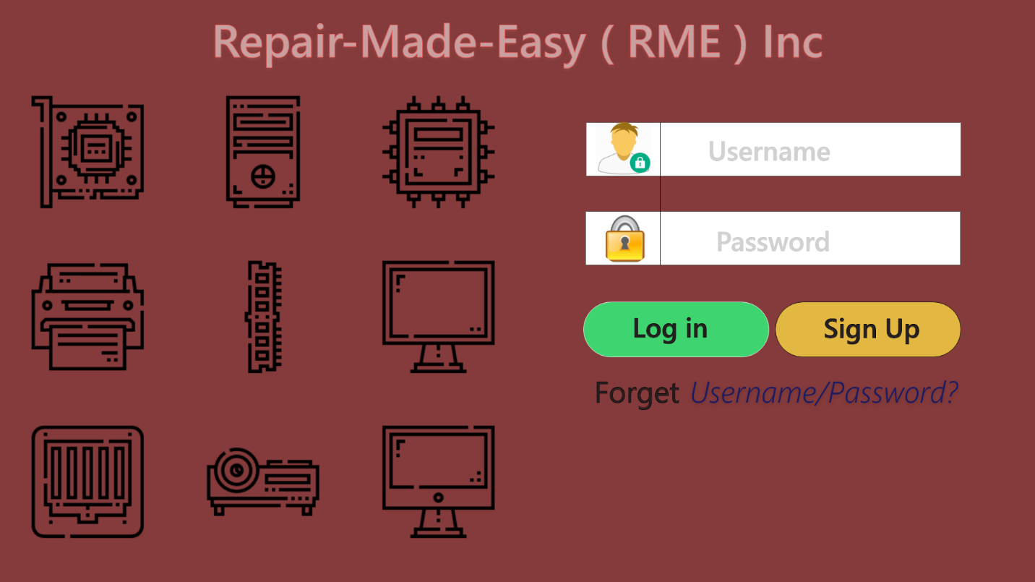

Fig 6: Login Page

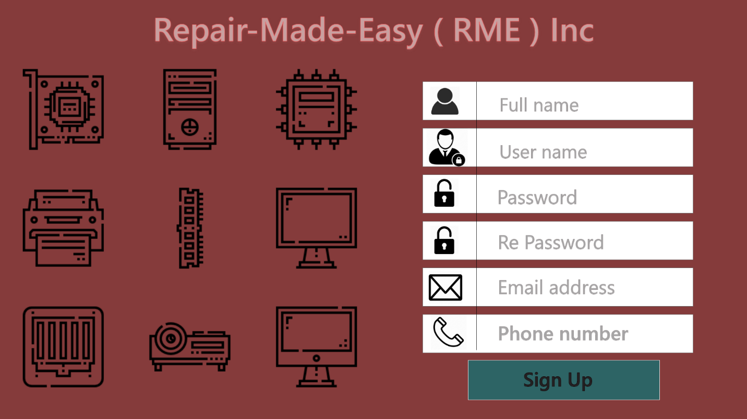

Fig 7: Sign Up Page



Fig 8: Home Page

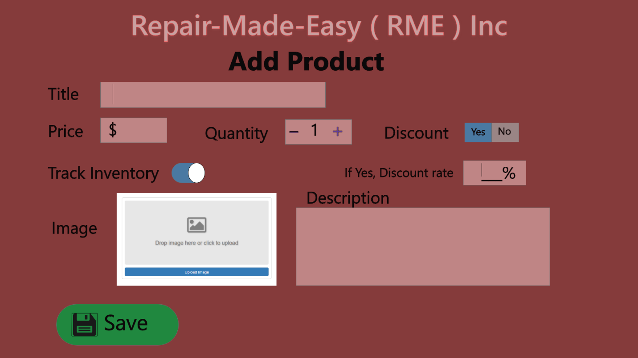

Fig 9: Add Product Page

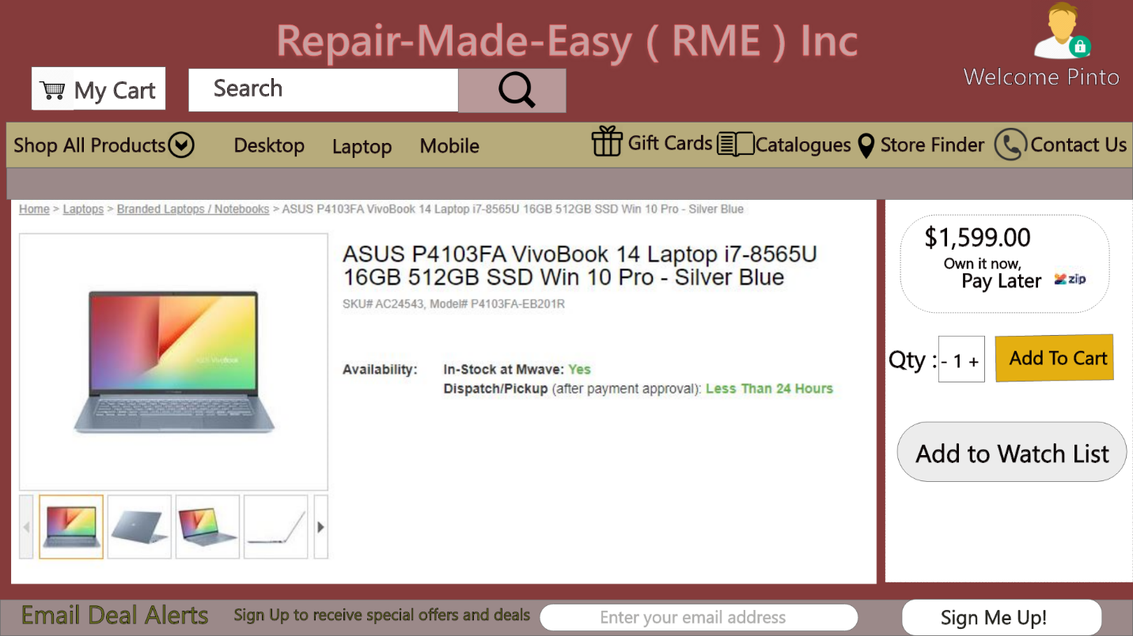

Fig 10: Product Detail and Add to Cart Page

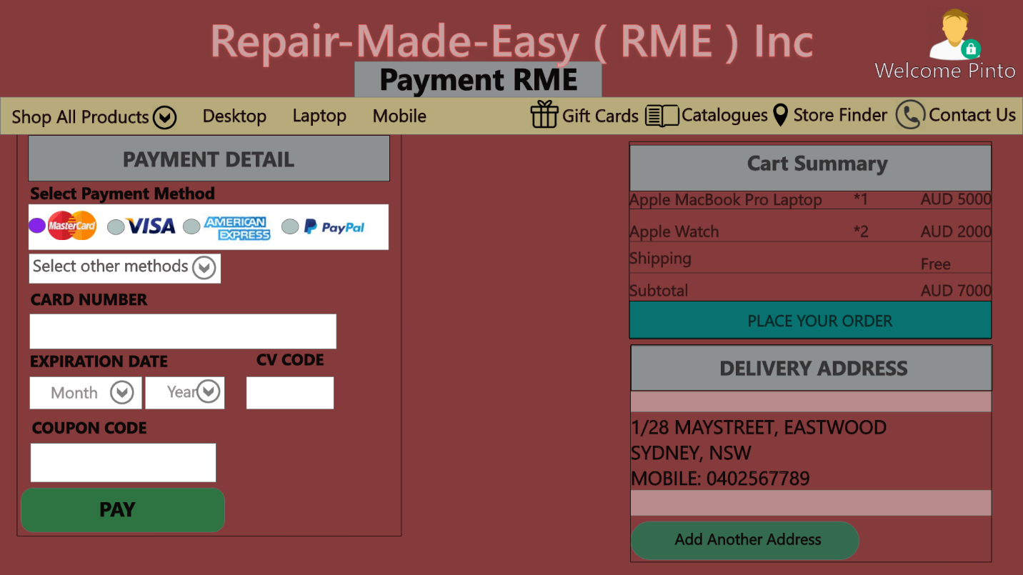

Fig 11: Payment Process Page

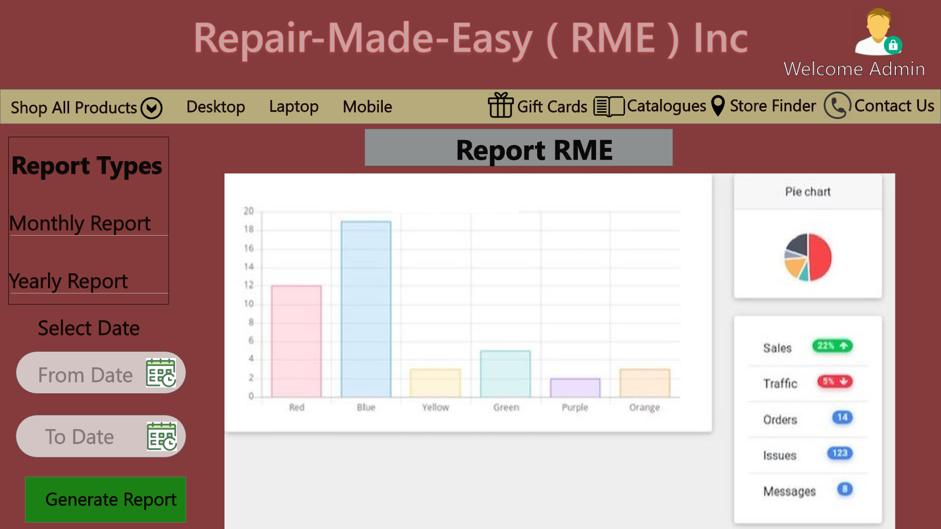

Fig 12: Report Generation Page

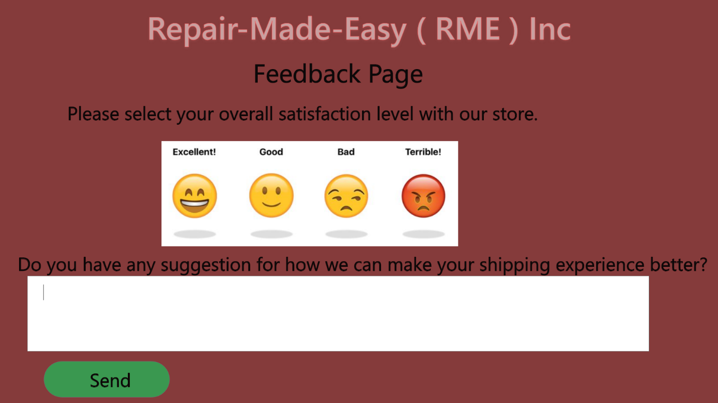

Fig 13: Feedback Page

# 9. Individual Contribution

There were four members in our group and the task were divided equally with all team members as per the discussion within the group. The following are the work contribution of each team member.

**Bishal Budhathoki (12116421)**

My contribution for this assignment is important as I have used my knowledge on

* Case Study: We initially had a member meeting and discussed the problem and figure out the ways to move forward for this assignment. I then assigned tasks to every members of the group considering what they are best in.
* Use Cases, Context level Diagram and Data Flow Diagram: We had a discussion between our team members to find out the all possible use cases and pick out the critical use case from them. With some help from the team, I prepared the Context level Diagram and Data Flow Diagram.
* Prototype Design: I helped out in making changes in the prototype by picking some faulty points.
* Presentation: Some contents for the PPT slides have been provided by me.
* Final Report: I took part in final compilation and made few changes.

**Rabina Prajapati (12117176)**

During the development of this project, I had contributed in

* Use Case: Firstly, I identified all the actors and the possible use cases for the system. I then identified the critical use cases and draw the use case diagram. Those use cases in diagram are operated by the relevant actors. Some of the use cases are extended to some other use cases as they are followed by the prior activity.
* ERD: In the ERD, I first identified entities present in the system with their relevant attributes. All entities are represented with their main key called primary key. Those primary key can be foreign key for different entities as they are connected with some kind of relation and dependencies.
* Presentation: For the presentation, I added content on topics like Introduction, key functional requirements, bottle neck of existing system.
* Final Report: Compilation of report and suggested changes.

**Ajay Mall (12123341)**

My contribution for this assignment is that I have gone through all the use cases and the functioning of the RME Information System, from all this information I have designed Data Element Table & CRUD diagram for RME Information System. In addition, I have also prepared the presentation slides.

In this group project, we have discussed and comes to result that we divided the part to each other and help them if they need. In my part, I must prepare data element table and CRUD diagram for the project. So, I have to required data from the DFD and context level diagram as well as entity relationship diagram to create data element and CRUD.

I have gone through various CRUD references where I have chosen the latest one and create the CRUD diagram. For data element table, I must well prepare for the primary key and foreign key where it is necessary in data element. At last, this is my contribution towards the group project where we are completing this project cooperatively and easily.

**Sakar Sainju (12120342)**

As per the discussion with the group, my part in the assignment was to develop the prototype for the RME website and to work on the Introduction and Conclusion part along with the documentation work. Since this assignment was the continuation of the previous assessment, I was aware of the RME Information System and how the system should work and how the system prototype should be.

As my main responsibility was to develop the prototype for the website, the first task I performed was the research on the website development tool. Various tools are used for the website prototype development like UXPin, Mockplus, Wireframe.cc, Moqups, Adobe XD, etc. Since I was familiar with the adobe tool, I chose the Adobe XD for the development of the prototype and hence installed the required software.

I analyzed the case study and designed some website pages that are deemed important and depicts the main functional requirement of the system. I first made the home page and discussed with the team members from which the required changes were made, and that page becomes the base page for the other pages. More pages like login page, sign up page, add to cart page, etc. were developed. My responsibility was also to write the introduction and conclusion part. I was also responsible for the documentation and merging the required task in the documentation process.

In this way, the task was completed in the group. The effective teamwork helped in the successful completion of the task and everyone's contribution was an integral part of the team.

# 10. Conclusion

The report specially discussed the system diagram and system models and system prototype for the Repair-Made-Easy. It provides the analysis of use case diagram, context diagram, data-flow diagram, CRUD and data elements. These all diagram analyzes the functional requirement of the new web-based RME system.

The prototype developed is dynamic and user-friendly and should help RME to achieve their estimated target and goals. A lot of enhancement will be made in the prototype system when discussed with the stakeholder. A healthy discussion from the stakeholders will make the requirement more clear and will help in the further enhancement of the new web-based Repair-Made-Easy.

# 11. References

Kendall, K & Kendall, J 2011, System analysis and design, 8th edition, Pearson Education, New Jersey

Rouse, M 2015, Use Case Diagram (UML use case diagram), WhatIs, January 2015, Viewed on 19 September 2019, <https://whatis.techtarget.com/definition/use-case-diagram>

Letsxd, n.d, Design Systems In Adobe XD, Letsxd, n.d, Viewed on 12 September 2019, <https://letsxd.com/design-systems>

Chi, C 2018,A Beginner's Guide to Data Flow Diagrams, HubSpot, 27 September 2018, Viewed on 15 September 2019, <https://blog.hubspot.com/marketing/data-flow-diagram>

Techopedia, n.d, Data Element, Techopedia, n.d, Viewed on 20 September 2019,<https://www.techopedia.com/definition/6740/data-element>